Training-of-Trainers (TOT) Program

Handout-of-Handouts

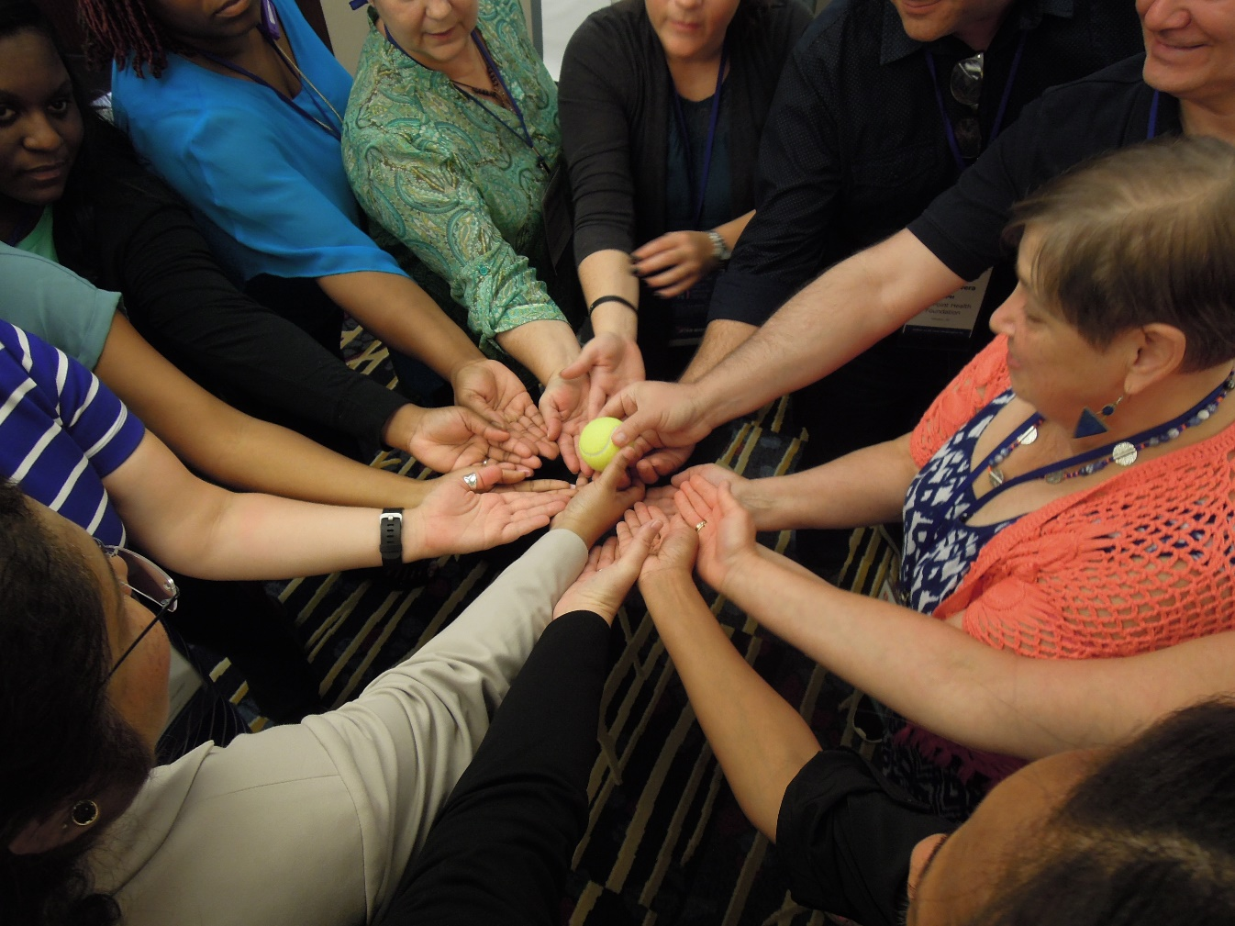

November 2018

How to Use This Resource
The revised TOT Handout-of-Handouts contains the most recent updates to the Training-of-Trainers (TOT) Program. We are pleased to announce that this document is compliant with Section 508 of the Rehabilitation Act of 1973 (as amended in 1998).
In addition, we have referenced the page number where the module can be found in the printed NQC Training-of-Trainers Guide (TOT Guide). You will notice that some content herein is labeled as revised content. This is to indicate that it replaces the original tool or case study in the TOT Guide.

Have fun at the TOT!

Module 1 Tool: Participant Introduction (TOT Guide p. 73)

This section is helpful to reflect on your participation in the TOT Program. It encourages you to focus on your goals for the training and offers others an insight into your thoughts and concerns about the TOT.

Identify 1-2 hopes you have for this learning experience:

Identify 1-2 concerns you have about this learning experience:

Identify a personal, meaningful story to illustrate how quality improvement has affected the HIV care you provide:

Module 1 Tool: Examples of Icebreakers

1. Cocktail Party
• For use with larger groups
• Ask people to circulate and speak to 1 person at a time to get acquainted
• After 1 minute, announce “CHANGE” and have everyone find another person to get acquainted with
• Continue changing every minute until most people have had the opportunity to meet each other

2. True and False (Three Truths and a Lie)
• For use with small groups sitting together
• Ask each person in the group to list four facts about themselves on a piece of paper; three of those facts should be true and one should be false
• One person in the group begins by reading their items aloud and the group tries to guess which one is false
• The person in question reveals the false item
• The others in the group take their turn until everyone has participated

3. Dreams & Nightmares
• Each person describes a “dream” about something
positive they hope will happen in this course
• Each person describes a “nightmare” about something they hope will not happen on this course
• Put the dreams and nightmares on a flip chart so all groups can read them

4. Five Guests
• Each person reports to their groups as follows:
if you could have any 5 people, living or dead, as guests in your home for an evening, who would they be and what would you talk about
• After hearing from everyone, the group selects their “all-star” team of 5 guests; put these on a flip chart

5. Group Resume
• Small groups put their collective resume on a flip chart. Have them list:
- Degrees, diplomas
- Previous jobs held
- Courses they have taught
- Hobbies
- Major skill areas

Module 1 Tool: Ice Breaker Exercise (TOT Guide p. 75)

Directions:
You have typically 10 to 12 minutes for this exercise. Go around the room and ask your peers if they have done any of the activities listed below. Check off an attribute each time someone answers in the affirmative.

Objective:
The objective of an ice breaker is to overcome the natural resistance many individuals feel when participating in larger groups. Individuals should be encouraged to move around the room and interact with their peers. Ice breakers facilitate the interaction of peers and assist in building informal networks as the training progresses.

Find someone who:
- Has participated on a quality improvement team
- Has lived their entire life in the same city or town
- Has a graduate degree
- Owns a motorcycle
- Has participated in a marathon or a triathlon
- Has conducted a training program for a group of 10 or more people
- Fluently speaks one other language
- Has facilitated at least 1 quality improvement team
- Plays a musical instrument
- Participated in any type of intercollegiate sport while in college
- Can explain what the letters PDSA means
- Has a family member living outside of the USA

Module 4 Tool: QI Principles in Action Worksheet (TOT Guide p. 82-83)

Group Exercise
Based on your experiences in providing health care, find at least one concrete, real life examples to clearly illustrate each QI principle. Discuss in the group and document one example for each principle on this worksheet and report back to the larger group.

- “Success is achieved through meeting the needs of those we serve.”
_______________________________________________________________________________________________________________________________________________________________________________________
- “Most problems are found in processes not people.”
_______________________________________________________________________________________________________________________________________________________________________________________
- “Do not reinvent the wheel—Learn from best practices.”
_______________________________________________________________________________________________________________________________________________________________________________________
- “Learn from small incremental changes to achieve continual improvements.”
_______________________________________________________________________________________________________________________________________________________________________________________
- “Actions are based upon accurate and measured data.”
_______________________________________________________________________________________________________________________________________________________________________________________
- Infrastructure enhances systematic implementation of improvement activities.”
_______________________________________________________________________________________________________________________________________________________________________________________
- “Set Priorities and communicate clearly.”
_______________________________________________________________________________________________________________________________________________________________________________________

Module 8 Tool: CQM Infrastructure (TOT Guide p. 96)

Based on your CQM infrastructure assessment findings, complete the following worksheet by listing three strengths and three challenges of your CQM program

Strengths of Your Clinical Quality Management Program:
__________________________________________________________________________________________________________________________________________________________________________________________________________________________________________________________________________________________________________________________________________________________________________________________________________________________________________________________________________________________________________________________________________

Challenges to Your Clinical Quality Management Program:
______________________________________________________________________________________________________________________________________________________________________________________________________________________________________________________________________________________________________________________________________________________________________________________________________________________________________________________________________________________________________________________________________________________________________________________________________________________________________________________________

Module 8 Tool: QM Action Plan (TOT Guide p. 97)

Based on your quality management infrastructure findings, develop an action plan to strengthen your CQM program. A well-developed action plan details each step, by when it will be executed, and by whom.

Action Plan:
Action Step | Detail | By When | By Whom

Module 9 Tool: Adult Learning Quiz

1. Subject matter experts typically are:
a) Consciously competent
b) Consciously incompetent
c) Unconsciously incompetent
d) Unconsciously competent
2. Which of the following physical factors affects learning?
a) Noise level
b) Time of day
c) Structure
d) Room temperature
e) All of the above
3. A standard way to keep people engaged in learning is to:
a) Summarize key points frequently
b) Use dramatic gestures to make points more forcefully
c) Ask good questions and allow people time to think & respond
d) Repeat key points numerous times to support short term memory
4. Which of the following are not preferences the instructor must recognize?
a) Participant’s apparel
b) Learning style
c) Setting
d) Motivation
e) Social needs

5. Of the following options, which is the most learner-centered?
a) Case study
b) Role play
c) Self assessment
d) Large group discussion
e) Lecture
6. Which is correct? We tend to remember:
a) 30% of what we hear
b) 50% of what we read
c) 20% of what we say
d) 90% of what we say and do
e) None of these is correct
7. Which of the following is not an example of active involvement?
a) Making a presentation
b) Participating in a discussion
c) Watching a demonstration
d) Engaging in a simulation
8. Left untreated, information disappears from short term memory in:
a) 3-5 minutes
b) 60 seconds
c) 30 seconds
d) 15 seconds
e) None of the above

9. Visual learners prefer, enjoy or require:
a) Written material to study new concepts
b) A good joke or story they can repeat or tell to others
c) Gestures when making a point
d) Frequent breaks to rest their eyes
e) Words to accompany a cartoon
10. Research suggests people learn best when:
a) There is lots of detailed content
b) They are shown how things are done
c) They see what’s in it for the organization
d) They get to try things for themselves
e) They are told how things work
11. Learning is defined as:
a) Retaining facts accurately in long term memory
b) A change in behavior due to experience or continued practice
c) Successfully driving knowledge from core skills sets
d) Correctly replicating in a work environment techniques discussed in a session
12. Which of these learning conclusions are false?
a) Adults resist situations where they are not treated with respect
b) Adults will strive to do their best when they are physically comfortable
c) Adults prefer a serious, no nonsense tone to maximize learning
d) Adults prefer practical results from learning
e) Teachable moments are determined by the adults needs and interests

Module 14 Tool: Five-Step Training Model (TOT Guide beginning 110)
Using this simple 5 Step Training Model to design your training program will help your learners learn and grow.
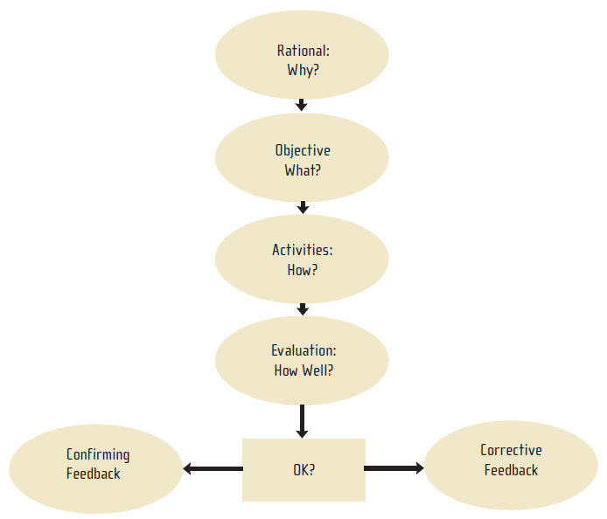
Think about the creation of a QI workshop, for example a one-day workshop with 20 participants, over the next several months. Consider the participants’ organizational knowledge and resources, the potential competencies of individuals, and key outcomes you wish to achieve. Use this template to complete a high-level Five-Step Training Plan to support your training.

A) Background Information:

Step 1: Topic & Rationale
- Engage your learners in a dialogue about why they need your program, and what is in it for them to attend, engage, and practice new learning and performance. Your rationale needs to address and enhance their motivation to learn and change.

In delivering the rationale, you will also state the title of the topic area you wish to teach. Make sure the topic is not too general. You should be able to teach each topic in one segment.

Step 2: Performance Objectives
Ask yourself “What is it I want the employee to be able to DO after this session?” The answers are your learning objectives. Learning objectives are demonstrable behaviors. They begin with action verbs such as: to list, to state, to count. They do not begin with the words “to know “ or “to understand.” Learning objectives provide specific goals which everyone in your training should be able to attain.

Step 3: Activities
- Learners are most engaged when they are active participants who are “doing instead of listening.” What activities and methods will you provide to your learners to help them embrace the materials? Activities should be focused on support of the learning objectives. They should have some of the following characteristics:
  - Engaging
  - Fun
  - Inherently Interesting
  - Provoke creative participation
  - Spark curiosity, but not confusion

- CQII has several resources that provide active learning activities around quality improvement and management principles and methods. For example, the NQC Game Guide includes a list of 20 games designed to engage learners in QI tools, methods, and concepts.

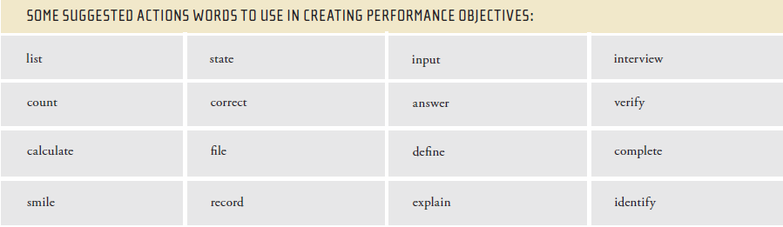

Step 4: Evaluation
It is important to assess whether participants have met learning performance objectives. When assessed, there is a much better chance participants will learn. Be sure to evaluate the learning performance and not the person doing the learning. Adult learners are sensitive and have strong feelings about learning situations, so be sure to set up any kind of evaluative activity in a way that stresses accomplishment.

Step 5: Feedback
Research shows that when learners receive feedback on how well they are learning, they learn better. Note that there are two types of feedback, corrective or confirming. Adult learners expect corrective feedback, and may be defensive about it. Adult learners will respond more favorably to genuine confirming feedback.

B) Case Study Practice Session: Moving from Assessment to Design
Think about a one-day workshop with 20 participants over the next several months. Consider their organizational knowledge and resources the potential knowledge and skill of individuals and key outcomes you wish to achieve. Use this template to complete a high level, 5 step training plan to support your training.

General notes about the situation and participants:

Step 1: Topic & Rationale
In this step, you need to communicate with and engage your learners in why they need your program, and what is in it for them to attend, engage, and practice new learning and performance. Your rationale needs to address and enhance their motivation to learn and change. Given what you know from your experience with groups like this, how will your quality program benefit this particular group of learners, and why do they need your program? How can you validate your rationale prior to the program?

Step 2: Performance Objectives
Ask yourself: “What is it I want the learner to be able to DO after this session?” Learning objectives are demonstrable behaviors. They begin with action verbs such as: to list, to state, to count. They do not begin with the words “to know “ or “to understand.” Learning objectives provide specific goals which everyone in your training should be able to attain. The number of objectives depends on the outcomes you want to achieve, the time available to you and the participants, and their prior knowledge and experience.
List potential learning objectives for your participants:

Step 3: Activities
Learners are most engaged when they are active participants who are “doing instead of listening.” What will you provide to your learners to help them embrace your materials? Activities should be focused directly on support of the learning objectives. They should have some of the following characteristics:
• Engaging
• Fun
• Inherently Interesting
• Provoke creative participation
• Spark curiosity, but not confusion
What activities will you conduct for this group and why?

Step 4: Evaluation
Evaluation is an important element to determine whether or not you and the participants have met the program objectives.
How will you assess participants on each learning objective?

Step 5: Feedback
Research shows that when learners receive feedback on how well they are learning, they learn better.
How will you provide feedback to learners, and how can you decrease any defensiveness they might naturally feel?

Module 14 Tool: Five-Step Training Model Sample Plan

Scenario:
You want to train consumer representatives from HIV programs across the region identified by HIV Program Directors, self-nominations, and chairs of local Consumer Advisory Boards (CABs). These consumers will become active members of future quality management committees and QI teams. You have assessed their training needs and found the following:
1. Online survey was conducted to potential training participants about their QI competency needs, past training background and experiences, and current involvement in QI activities
2. One webinar was held in advance of training to ascertain their local needs and allowed for discussion on personal reflections and training needs

Step 1: Topic & Rationale
Focus of consumer trainings:
A) Health numeracy/performance measurement
B) Working in QI teams
C) Understanding the local HIV Care Continuum

Current consumer participants should become – and are actively advocating to become - visible QI champions within their community and become active members on new CQM committees. This allows consumers to advocate for themselves and make sure QI activities align with their needs.

Step 2: Performance Objectives
A) Health numeracy/performance measurement
- Consumers understand the data so that they can present clinic data back to the CAB
- Actively participate in development of new measures as part of ongoing QI teams
B) Working in QI teams
- Give consumers the skills necessary to facilitate future QI team meetings
C) Presentation of local HIV Care Continuum
- Understand complexities and application of HIV Care Continuum data on testing linkage, retention, and viral suppression

Step 3: Activities
A) Health numeracy/performance measurement: TCQ Module
B) Working in QI teams: TCQ Module
C) Presentation of local HIV Care Continuum: Data presentation by regional quality coordinator

Training Activities
In addition to the presentation, quality improvement exercises will be used to reinforce the lesson of the presentation:
1. Ice Cream Container Exercise will use a practical walk through of the product information on the back of an ice cream container; this will reinforce lessons on how to interpret and use data
2. Tennis Ball Game will reinforce the idea of working together to achieve a common goal. An alternate will be the Stranded on the Moon Game

Step 4: Evaluation
Evaluation occurs on two levels:
1. A comparison of pre-training and post-training surveys focusing on core QI competencies (not more than 5 questions) to assess skills/knowledge acquired
2. Completion of a post-session (after each of the 4 training sessions) survey form, focusing on session facilitators, room, learning environment, effectiveness of resources, etc.

Step 5: Feedback
Feedback occurs on two levels:
1. Consumers will receive feedback concerning their knowledge gains over the training and for suggestions on improving competencies
2. Consumers will also have a chance to evaluate all aspects of the training with an emphasis on what went well and what could be done better in future trainings

Tool: Evaluation Summary

Kirkpatrick Evaluation Summary

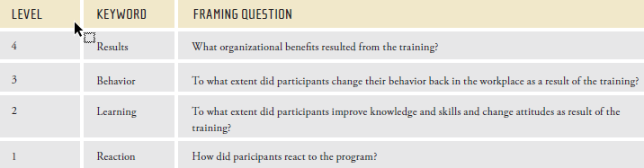

How do you conduct an evaluation? Consider these sources of information. What are the considerations when choosing a level?

Level 1 – Reaction
• Participant questionnaires
• Informal comments from participants
• Focus group sessions with participants

Level 2 – Learning
• Pre- and post-tests
• On-the-job assessments
• Supervisor feedback

Level 3 – Behavior
• Multi-rater feedback including a self assessment
• On-the-job observation
• Reports from participant’s customers, peers and manager

Level 4 – Results
• Performance measures, scorecards, outcomes
• Patient satisfaction scores
• Interviews with patients and families

Tool: Sample Training Evaluation Form

Training Session:
Date: / / Instructor:

Please indicate how important you consider this course to be by circling the appropriate number. Use the following scale:

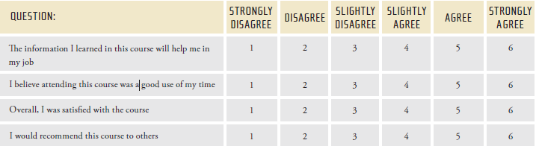

Additional comments/suggestions:

What should be given more emphasis:

What should be given less emphasis:

Course Materials and Exercises:
Please indicate your reaction to the course materials and exercises. Use the following scale:

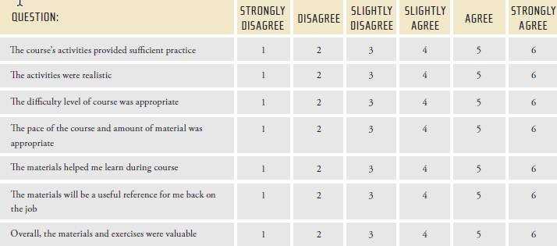

Additional comments/suggestions:

Familiarity with the subject matter prior to attending this course:
________ No familiarity
________ I know what it is but I have never used/practiced it
________ I know it and use/practice it frequently
________ I am very familiar with it and consider myself very knowledgeable

Instructor:
Please indicate your reaction to the instructor for this course. Use the following scale:

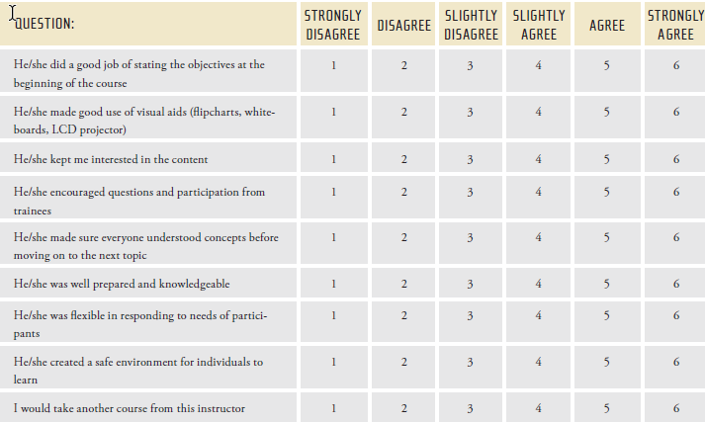

Additional comments/suggestions:

Tool: Fist of Five

This approach uses a simple visual process for facilitators to collect feedback from participants on a learning experience, module, section, exercise, activity, etc.

Set-Up
1. Tell participants you’d like feedback on a particular training component.
2. Tell participants they can use a hand and their fingers to provide you quick feedback using a 1-5 scale.
3. Say, “I’ll ask you a few questions about this last activity. If you thought it was excellent, hold up 5 fingers. If you thought it definitely needs improvement, hold up 1 finger. If you thought it was satisfactory, hold up 3 fingers.
4. Then say, “For this last activity, WIN AS MUCH AS YOU CAN, how was…”
a) The explanation of the rules to play …
Then say, “Hold up 1-5 fingers, 5 was excellent, 1 was needs improvement” Get a feel for the general pattern of the response and say, “Looks like most of you thought it was satisfactory.” Move to the next question.
b) The debrief discussion following the activity…
Again say, “Hold up 1-5 fingers.” After you mentally tabulated the feedback say, “Looks like most thought it was very good to excellent. Good! ”

c) What about applicability of the activity to your work situation…
Again say, “Hold up 1-5 fingers.” After looking at the feedback say, “I’m seeing more 1’s and 2’s than I’d like to see. Let’s discuss how WIN AS MUCH AS YOU CAN relates to your work situation. Here is how I see it….”

After providing your perspective and listening to the
perspectives of others on applicability, ask those who gave the 1’s and 2’s if the discussion was helpful.

Summary
Use this feedback method to understand how to better set up an activity or presentation, develop better examples or anecdotes, more deeply explain the rationale around a topic, allow more time for the de-brief and discussion, provide written instructions for people rather than verbal, etc. It’s best used immediately after the area you’d like feedback on and should involve a limited number of questions, about 3-5.

What did you like the most about this course?

How could this course be improved?

Name (optional): ____________________________________________________

Thank you for your time. I appreciate your feedback!

Module 15 Tool: Performance Measurement Indicator Worksheet (TOT Guide p. 118)

Establish your QI Project Title:
____________________________________________________________________________________________________________________________________

Set Your Goal:
____________________________________________________________________________________________________________________________________
____________________________________________________________________________________________________________________________________

Decide on Your Indicator:

Denominator
____________________________________________________________________________________________________________________________________
____________________________________________________________________________________________________________________________________

Numerator
____________________________________________________________________________________________________________________________________
____________________________________________________________________________________________________________________________________

Module 15 Tool: Performance Measurement: Overview & Group Exercises

HAB/OPR Measures: Sample Data from the State of Euphoria Parts A, B, C and D Programs
 |  | Viral Suppression | Medical Visits | Retention | ARV
Facility | Cases | Results
 | No: | % | % | % | %
1 | 14 | 79 | 75 | 100 | 100
2 | 1275 | 57 | 60 | 92 | 91
3 | 509 | 52 | 83 | 91 | 92
4 | 3392 | 51 | 77 | 85 | 98
5 | 214 | 77 | 88 | 99 | 100
6 | 2294 | 69 | 83 | 99 | 97
7 | 195 | 81 | 72 | 98 | 100
8 | 92 | 58 | 70 | 95 | 92
9 | 484 | 51 | 74 | 99 | 95
10 | 172 | 54 | 70 | 85 | 98
Median |  | 62% | 75% | 99% | 97%

Module 18 Tool: List of Training Topics (TOT Guide p. 126 - 137)

Topic Selection by Participants:
Please select from the list below a topic to develop into a Training Module:
• How to write and update quality management plans
• How to build a sustainable quality management infrastructure
• Choosing HIV quality measures, collecting performance data
• Using data to prioritize improvement activities
• Using teams to improve quality
• How to use the PDSA Cycle to accelerate improvements in HIV care
• Involvement of stakeholders (staff and consumers) in quality improvement
• Importance of leadership in implementing and sustaining QI activities

Learning Objectives:

Participants will:
Participants will:
Participants will:
Participants will:
Participants will:

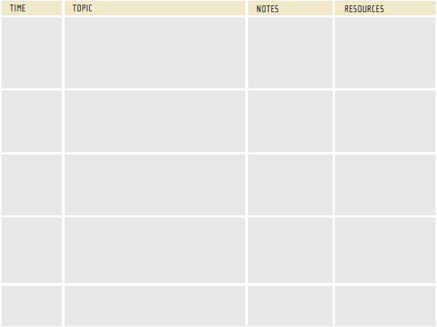

Module 18 Tool: Sample Day at a Glance (DAAG)
Training-of-Trainers (TOT) Agenda: Tools for QI in HIV
2.5 Day Session

Learning Objectives:
Participants who successfully complete the entire Training-of-Trainers Program, including the pre-work assignments will be able to:
• Demonstrate quality improvement principles and their application to HIV care, including the requirements for quality set by the Ryan White Program.
• Design appropriate and helpful adult learning experiences that measurably advance quality improvement within other grantee and sub-grantee’s care settings.
• Increase their confidence in facilitating quality improvement related training opportunities in HIV care environments.
• Effectively plan the meeting logistics for upcoming workshops, including registration, meeting environments, and workshop evaluation.

Day 1: A.M. Overview

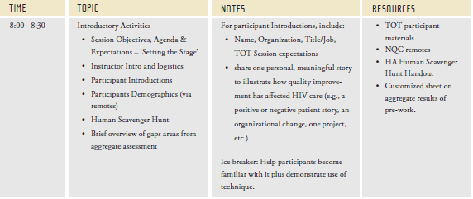

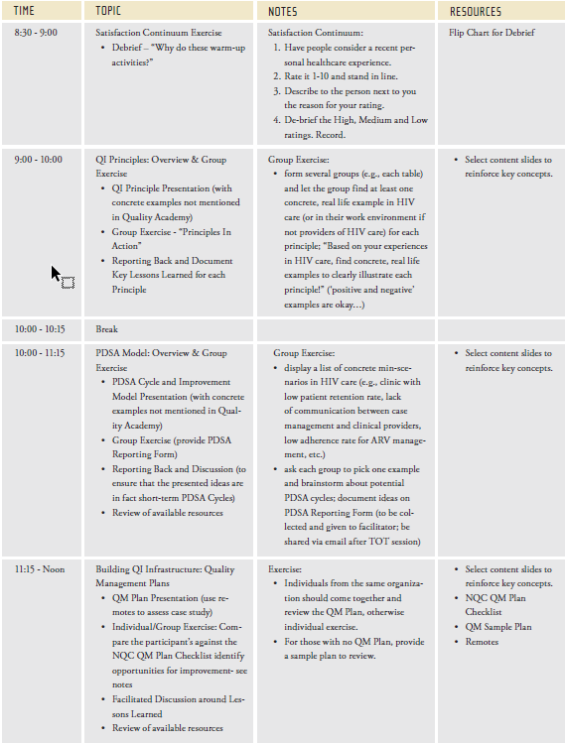

Module 18 Tool: Individual Training Design

Here is a step-by-step guide for creating your session plans. Use this guide as a blank session plan you can use as an original. Simply make a copy of it for each session you plan to present.

Session Title: ______________________________________________________

Target Audience: ___________________________________________________

Time Allotted: _____________________________________________________

Rationale:

Objectives:

Activities:

Evaluation:

Feedback:

Module 18 Tool: Faculty Notes Template

A) Faculty Notes – Module #
Title of Activity: _______________________________________________

Agenda Day and Time: __________________________________________

Type of Activity: _______________________________________________

Materials Needed: ______________________________________________
_____________________________________________________________

Overview of Activity – min:
• _____ min:
• _____ min:
• _____ min:
• _____ min:

Purpose and Key Lessons Learned:

Detailed Instructions:
______ mins

Reference Materials:

Module 18 Tool: Sample Faculty Notes
Faculty Notes - Performance Measurement: Overview & Group Exercises

Title:
Performance Measurement: Overview & Group Exercises

Agenda Item:
10:30am – 12:15am (105min)

Type of Activity:
Presentation with PowerPoint slides; Group Exercises; Group Discussion

Materials Needed:
Presentation slides (“Performance Measurement”); copies of Group Exercise handouts (‘PM Quiz”, “PM Indicator Worksheet” and “PM Data Collection Worksheet”); flipchart

Overview of Activity – 105min:
• 15 min: Introductory Performance Measurement Quiz
• 20 min: Performance Measurement Presentation on Indicators
• 20 min: Group Exercise - “How to develop an indicator”
• 20 min: Performance Measurement Presentation on Data Collection
• 15 min: Group Exercise - “How to sample records”
• 15 min: Group Discussion
Purpose and Key Lessons Learned:
• Understand the key concepts on how to develop and write an indicator definition

• Learn about data collection processes and sampling methodologies
• Familiarize participants with available resources around performance measurement in HIV care
• Share with others lessons learned around performance measurement
Detailed Instructions:
Introductory Performance Measurement Quiz - 15 min
1. Hand out copies of Group Exercise handouts, named ‘PM Quiz’
2. Ask one participant to respond and explain rationale; ask for feedback by other participants
3. Review the answers with the audience and discuss
elements of a sound data collection system
Performance Measurement Presentation on Indicators - 20 min
4. Present the appropriate PowerPoint slides, named
‘Performance Measurement’ with focus on the reasons for performance measurement and around quality indicators in HIV care
5. Engage the participants to share their data collection experiences

Group Exercise - “How to develop an indicator”- 20 min
6. Form several small groups of 5-8 individuals; it is
suggested to use each table as one group
7. Hand out the ‘PM Indicator Worksheet’ exercise to
each group
8. Introduce the exercise and let each group define one indicator based on several presented examples (retention of care; coordination of care; consumer involvement
in care)
9. Make faculty members available to teams
10. Ask 1-2 teams to report back their definition; ask for feedback by other participants and faculty
Performance Measurement Presentation on Data Collection - 20 min
11. Present the appropriate PowerPoint slides, named
‘Performance Measurement’ with focus data collection in HIV care
12. Engage the participants to share their data collection experiences
Group Exercise - “How to sample records”- 15 min
13. Form the same small groups of 5-8 individuals as before
14. Hand out the ‘PM Data Collection Worksheet’ handout to each group
15. Introduce the exercise and ask each group to identify
the appropriate number of male and female records to
be pulled
16. Share the results with all groups

Group Discussion - 15 min
17. Facilitate a group discussion among all participants around the question: “What are the Do’s & Don’ts of Performance Measurement?”

Reference Materials:
• NQC Quality Academy – Online training courses on quality improvement in HIV care; 2006; selected
tutorials:
- Tutorial 7: Acting on Measurement - Overview
- Tutorial 8: Choosing Quality Measures for HIV Care and Services
- Tutorial 9: Collecting Data
- Tutorial 10: Narrowing Your Focus – Using Data to Select an Improvement Project
• ‘Measuring Clinical Performance: A Guide for HIV Health Care Providers’ – Publication by the New York State Department of Health AIDS Institute; updated 2006
• ‘HIVQUAL Workbook: Guide for Quality Improvement in HIV Care’ – Book by the New York State Department of Health AIDS Institute, National HIVQUAL Project (www.hivqual.org); 2006
• HIVQUAL3 Software – HIV Data Collection Software by the New York State Department of Health, AIDS Institute, National HIVQUAL Project; updated 2006

• HIVQUAL Group Learning Guide: Interactive Quality Improvement Exercises for HIV Health Care Providers’ - Facilitator guide of the New York State Department of Health AIDS Institute; updated 2006; selected exercises:
- Constructing a Sample
- Data Collection
- Putting it All Together: An Improvement Project Cycle
• ‘Patient Satisfaction Survey for HIV Ambulatory Care’ - Publication by the New York State Department of Health AIDS Institute; 2003
• ‘Measuring Quality Improvement in Healthcare’ – Book by R.G. Carey, and Lloyd, R.C.. New York: Quality Resources, 1995
• Group Techniques for Program Planning: A Guide to Nominal Group and Delphi Processes – Book by Delbecq, A., Vand de Ven, A., and Gustafson, D.. Middleton, WI: Green Briar Press, 1975/1986
• ‘An Introduction to Categorical Data Analysis’ – Book by Alan Agresti, Wiley Series in Probability and Statistics. Applied Probability and Statistics, May 1996

Module 18 Tool: Five Step Model

Feedback Sheet

Feedback For: ________________________________ Date: _________________

Topic or Subject of Training:___________________________________________
__________________________________________________________________

Step 1: Topic & Rationale
What did the presenter do well in communicating with and engaging learners in why they need their training program?

What else might they do to better engage their learners?

Step 2: Performance Objectives
Did the presenter provide clear, behavioral learning objectives?

What other words or phrases could they use to provide actionable, behavioral objectives, if any?

Step 3: Activities
How well would the activities the presenter chose engage their adult learners?

In what ways can you suggest to make the activities more interesting, fun, or creative for adult learners?

Step 4: Evaluation
Did the presenter use appropriate evaluation tools or methods? What seemed to work well with them, and what other evaluation methods or tools would you suggest for this content?

Step 5: Feedback
How well did the presenter do in building in check points or ways to provide feedback to participants on how well they learned
the material?

What other ways or places in the training can you recommend for providing feedback?

Module 24 Tool: 10 Pre-flight Tips & Advice (TOT Guide p. 175)

• Are you prepared to arrive at least 45 minutes before the session to prepare and set-up?
• What equipment will you need? Confirm it will be there at least the day before and use some of the early arrival time on training day for set-up and testing.
• Identify and meet with the person responsible for troubleshooting technical/equipment issues before the session begins. Consider what back-up plan exists in the event your laptop crashes, projector bulb burns out, etc.
• Are you familiar with the training location, rest rooms, handicap access, fire exits, etc. If you’re unfamiliar with the location, add 5 minutes to your early arrival time.
• If you are responsible for room set-up, see if you can do it the night before or the morning of an afternoon session. Having 3-5 participants at small tables works well.
•Do you have your hands on the participant materials.
If no, who does and how will they get to the training location?

• Distribute materials in advance at the small tables, face down in an organized stack. Have each hand-out a
different color to help with distribution.
• Allow for some quiet time before the beginning of the session to center yourself. Review the first 15-30 minutes of the content and facilitation notes so they are fresh in your mind.
• Review housekeeping items such as breaks, lunchtime, fire exits, groundrules, etc. before you begin the session.
• And remember, it’s not about you, it’s about the learners. Be flexible, relax, have fun and know their will be glitches as you go. If you don’t overreact when problems occur, it’s likely your participants won’t either.

Module 24 Tool: Presentations and Facilitation Skills (TOT Guide p. 177-184)

Detailed Notes: What We Hear and See
Most of us can remember a few of the hundreds or thousands of presentations we have seen. One thing that makes the memorable ones stand out is the way they were presented. Depending on when you were born, you may remember key political or social action speeches, like those of John Kennedy at his inauguration or Martin Luther King, Jr., in his “I Have a Dream” speech. You may remember a speaker at a service club or a sermon. What most often sets the memorable ones apart is the way they are presented, even more than the content. There is great power in personal conviction; your confidence in what you are saying shows through.

How we are received is dependent on what people in the
audience hear and what they see. In this segment, we will consider what people hear and see when they hear and see us.

Volume
• People are not impressed by what they cannot hear, so speak loudly enough to be heard and use sound systems carefully.
• Generally, people don’t like to be yelled at and don’t tolerate loud noise well, so don’t speak too loudly.
• Find a happy medium and vary your volume at least a little, depending on the content of your presentation.
• (Demonstrate by speaking very loudly, very softly, and in-between to the group.)

Pitch
• We each have a natural range of pitch, so we can’t make radical changes in the pitch of our voice. We can make the most of what we have and who we are, though.
• “What are the advantages and disadvantages of a presentation delivered in a consistently high pitch?” “In a consistently low pitch?”
• You’ll keep people’s interest best if you vary your pitch within your natural range and use other “sound effects” only to make a point or draw attention to one aspect of your presentation. People might be lulled by a low, flat pitch (like driving in Kansas) and/or they might be set “on edge” by a consistently high pitch (like driving in the Rocky Mountain passes in Colorado).
• (Demonstrate a range of pitch as you speak a sentence.)

Pace
• The rate one person can talk and present information, and the rate another person can understand and absorb information can be quite different! It doesn’t accomplish much if you PRESENT a huge amount of information; it matters if your participants UNDERSTAND and RETAIN what you are presenting.
• Too fast a pace might mean that you leave a portion of the audience back in the dust of your ideas. Too slow a pace will tempt people to do other things with their mind, attention and energy.
• Luckily, there is a broad area in the middle where everyone can be comfortable. Comfort is especially important for the speaker - comfort with the material, with the environment, with the audience, with the processes and audiovisuals used. As a presenter, try to maintain a high “comfort” level and that will help keep you going at the right pace.
• “What kinds of factors can make a presenter go too fast?” “What can be done to address each of these factors?”
• “What kinds of factors can make a presenter go too slowly? What can be done to address each of these factors?”
• A very effective way to manage a fast pace is through pauses (see next section).

Pauses
• New speakers sometimes tend to be afraid of “dead air.” More experienced speakers are often better at using pauses. There are all kinds of pauses:
- dramatic pauses (before or after making a big point);
- catch your breath pauses;
- find your place in your notes pauses;
- pauses to let ideas sink in;
- pauses after you have asked a question but before anyone has answered;
- pauses to separate important concepts, ideas, or statistics;
- pauses between different parts of your presentation;
- pauses after the slide presentation but before the lights are on; etc.
• Don’t be afraid to use pauses. They can be very useful and can help you make points, gather your wits, and emphasize important points. There is a big difference between pauses and times when there is “dead air.” You might want to plan your pauses into your presentation. Write them in your outline.

Fillers
• Most of us have “fillers” that come very naturally to us (Um, Er, Hmm, you know, you guys, etc.). Most of these fillers can become quite distracting during a presentation. Is this a problem for you?
• “Why do you think people use fillers?” Gather answers.
“What can be done about fillers?”
“Does anyone have a success story for us about themselves or someone else who managed to rid their presentation of fillers? What was the successful strategy?”
• One way to stop using filler words is to ask for assistance in becoming aware of their use. It may seem obnoxious, but doing something like snapping fingers, just for 30 seconds or so, when someone uses a filler word allows them to become aware of their use.

What We See
• Now, let’s discuss how presentation skills are related to body language. Live presentations are different than audio tapes because there is a focus on the presenter, and different than video and TV because there is a live, interactive person standing there in three dimensions. Live presentations can be effective because there is a physical presenter, because people see what you do, how you move, what your “Body English” says about you.

Body Stance and Movement
• Let’s review a few different body stances. Take a few different body stances, such as the “defensive posture” (arms folded in front of your chest), or the Parade Rest gesture (arms behind you and your hands locked together behind you), or the “Fig Leaf” stance (arms in front of you and your hands clasped together).
• What is each stance expressing?
• Where your body is (close to participants, behind a podium, in the middle of the crowd) and how you move it send a loud message to the audience. Pacing back and forth before the audience while you speak does not necessarily support the meaning of what you are saying. In general, intentional movement can be more helpful when trying to support your points.
• What stance is most effective? Is a stance that presenters should avoid?
• Tell them what stances, positioning and movements have worked for you as a presenter.

Gestures
• If a person does not normally use gestures when they talk with one person at a time, should that person try to use gestures during a presentation to a group? Why or why not?
• Are some gestures more effective than others? Which ones?
• In general, gestures are useful if they aren’t contrived because it helps create a picture for your audience. Think again how adults learn, and you can see that some visual reinforcement might be helpful.

Facial Expression
• Since so much of what we experience as adults comes to us through sight, facial expression is an important component when we speak with others. As they say, “a picture is worth a thousand words.”
• Most people do not have much awareness about this “tool” and how it can impact an audience. The most dramatic example is when someone is nervous and perhaps frowning or has a neutral expression, and yet they say how happy they are “to be here.”
• What do you think as a listener when this happens?
• Take a moment and practice this with someone next to you. Try to show them with your facial expression that you are happy to see them, mad at them, and sad or nervous. Note how that feels to actually show that with your face.
• Have participants ask themselves: “How was my facial expression during my last presentation?” “Did my facial expression help or hurt my presentation?”
• “What kind of expression do I ‘normally’ have?” “Should I have my ‘normal’ expression during a presentation or should I try to look another way?”

Eye Contact
• What is the role of eye contact in communication in general? If you have children, what role does eye contact play in
communicating with them?
• Why is it important in presentations? Why is it hard to maintain eye contact?
• In general, you should try to maintain solid eye contact with a specific listener through the completion of a one continuous thought.

Nervousness
• Most facilitators with some experience teaching find that they are only really challenged by nervousness at the beginning of their presentations. Nervousness is a physiological response, and is generally related to a fear of the unknown. It is energy and it can escalate due to “fight or flight” physiological responses.
• One way to reduce nervousness is to minimize the “unknowns” which means knowing your material, your resources, and your participant’s needs and interests. Practicing in advance will help you control “nervous butterflies” and allow you to channel nervous energy into productive uses such as more volume, more pitch, supporting gestures, and more direct eye contact.

Detailed Notes: Creating and Using Visual Aids
Visual Aids: (show examples of different types of visuals from the PowerPoint)
• As is the case with your physical delivery skills, visual aids can either support your impact or reduce it. The purpose of visual aids is to re-enforce your message so that participants remember and retain your content. Visual aids
can easily become a distraction when misused or when poorly designed. How many times have you seen a word document with no graphics used as a visual aid?
Key points for the creation of visual aids include:
• Try to use pictures when possible.
• Use color.
• Limit the amount of text or bullet points on a PowerPoint or flip chart (chunk information into 5-9 pieces!).
• Ensure that participants will be able to see or read your visuals from wherever they might be in the room
you are in.
Key points for using visual aids:
• Don’t talk to your visual aids when presenting. Look at your visual to think about what you want to say and then talk to your audience using good, solid eye contact.
• Manage the mechanics of transitioning from visual to visual or handing out a visual separately from presenting the material. This applies to virtually all kinds of visual aids, whether flip chart or PowerPoint or handout.

Detailed Instruction: Facilitation and Managing the Group
Training is a blend of presentation and facilitation. It is
important to understand how to integrate facilitation tools and practices into your training in order to more fully engage participants in learning. In some cases, you will be challenged with difficult behaviors in the group, and it will be useful to have a method to manage the individual and group dynamics.
• What does the word “facilitate” mean, and how does it
apply to working with groups?
• The purposes of communication: facilitation helps more deeply engage others.
• The role of the facilitator can often be that of a “traffic cop.” The traffic cop is responsible for group learning and does that by exhibiting the following behaviors, which also have sentence stems attached to each behavior.
- Observing:
“There seems to be a concern that…”
“Perhaps it’s time to move on…”
- Clarifying:
‘What I hear you saying is…”
“Let’s review as a group where we are…”
- Focusing:
“Getting back to the agenda….”
“Can we park this issue for now and get back to our agenda item?”
- Stimulating:
“What ideas can we come up with…?”
“What might be other reasons for this situation…?”
- Balancing:
“Does anyone have another viewpoint?”
“Any other ideas?”
- Summarizing:
“To review the key points we’ve heard today…”
“Let’s look again at the decisions we’ve made…”

Dealing With Difficult Behavior
Learning is about change, and sometimes occasions will arise in which participants or group dynamics create difficult behaviors situations. These behaviors could be a result of resistance to change, misunderstanding, different styles between participants or the faculty, or other factors. The following steps are most often effective in dealing with difficult behaviors.

Prevention
Work done before a group or workshop convenes and work done during the first session can prevent many problems from ever occurring. Talk with participants before the first session and address problems which you think might occur. Build ground rules at the first session to define appropriate group norms and learning behavior. Remind participants that they are responsible for upholding and enforcing the ground rules.

Non-intervention
• Usually, when someone is acting in a difficult way, the first step you should take is not to intervene at all. Pause a moment and see if other participants handle the situation. Oftentimes, participants will bring others into line by referring to the Ground Rules, or by simply asking them to stop what they are doing.
• If the behavior continues, and no one else steps in, you might have to intervene. If the behavior is destructive like a personal attack, intervene immediately. Use your judgment about when it is appropriate to intervene. Intervening too frequently can inhibit learning and problem solving behavior among adults.

Low-level intervention
Relatively non-threatening techniques designed to short circuit the difficult behavior will frequently take care of the problem. A reference back to the ground rules may be all that is needed. Something as simple as a shift in eye contact or asking for input from another learner may stop the behavior.
Medium-level Intervention
• If the problem behavior is chronic, you may choose to talk with the individual between modules or at a break and offer constructive feedback. Your goal is to create an informal contract in which the person agrees to desired behaviors. This may require you to offer certain agreements, too. For example, “I will try to avoid teaming you with Mary on assignments again, but you need to agree to stop arguing with her during the session.”
• If the participant does not respond to your feedback or suggestions, a more assertive intervention may be called for.
High-level Intervention
If all else fails, you may have to deal with the offending behaviors in the presence of other participants. This is not a step to be taken lightly. A great deal of thought and preparation has to precede such a confrontation. Avoid blaming. Use constructive feedback and focus on problem solving. Stay focused on the behavior. Keep personalities and stereotypes out of it. This is a high-risk intervention. It can alienate others, even though they may agree with you. It can, however, be very effective in halting problem behaviors.
Tips for Preventing Behavior Problems:
• Prepare thoroughly for training sessions
• Practice specific comments you might use to intervene
• Have solutions prepared before problems arise
• When you have concerns, discuss them with the individual outside of the training setting
• Plan seating arrangements so that everyone can see everyone else
• Avoid creating “power” positions, like the head of the table or the corner of the room
• Ask participants what else they have tried to effectively manage difficult behaviors or dynamics in learning situations

Module 24 Tool: Tips for Dealing with Difficult Behavior

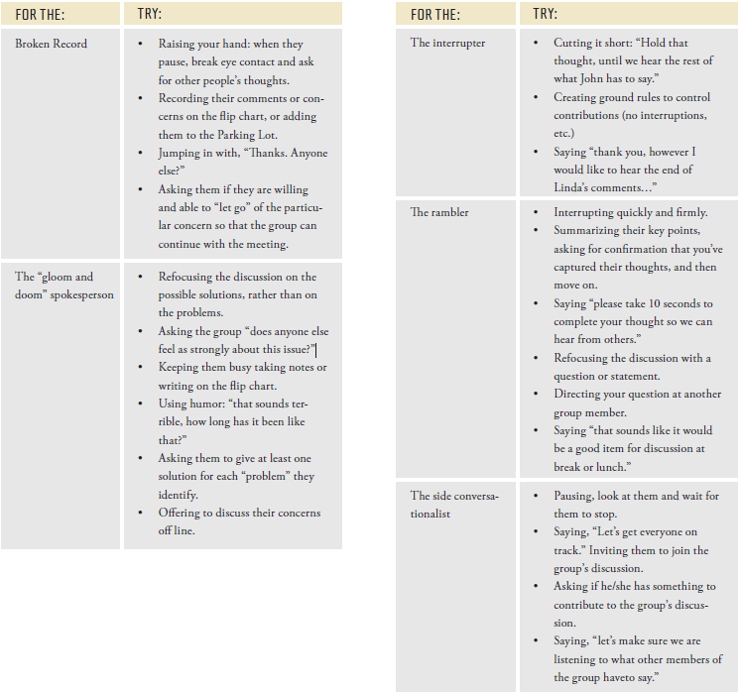

Module 26 Tool: Presentations and Role Play with Peers Feedback Form (TOT Guide p. 187)

What did the presenter do well in delivering their message? What could they have done differently to limit distractions and reinforce their message?
________________________________________________________________________________________________________________________________________________________________________________________________________________________________________________________________________

Consider the following elements of presentation skills and note helpful comments:

- Use of voice, volume, and intonation:
____________________________________________________________________________________________________________________________________

- Use of movement or gestures:
____________________________________________________________________________________________________________________________________

- Eye contact:
____________________________________________________________________________________________________________________________________

- Lack of filler words:
____________________________________________________________________________________________________________________________________

- Appropriate pace and pauses:
____________________________________________________________________________________________________________________________________

What did the presenter do well in facilitating learning? What might they have done differently?

- Allow group participation:
____________________________________________________________________________________________________________________________________

- Create comfortable learning environment:
____________________________________________________________________________________________________________________________________

- Establish common ground rules:
____________________________________________________________________________________________________________________________________

Module 27: Game Plan Going Forward (TOT Guide p. 190)

Name: ________________________ Organization: _________________________ Date: __________

